**MODUL 9. OBJECT & DRIVER CLASS**

**Capaian Pembelajaran Praktikum:**

* Create an Object class
* Create a Driver clasS

**Tools:**

* Java Development Kit (JDK)
* Eclipse

**Terminologi:**

Isikan terminology yang sesuai untuk definisi dibawah ini:

[…………………………………] A group of related Java classes.

[…………………………………] Sections of code that are enclosed inside a set of curly braces. {}

[…………………………………] First letter uppercase and the first letter of each internal word capitalized. Example: SavingsAccount

[…………………………………] A named value that does not change.

[…………………………………] First letter lowercase and the first letter of each internal word capitalized. Example: studentFirstName

[…………………………………] A class that contains a main method.

[…………………………………] A code statement in a Java class file that includes java code from another package or class.

[…………………………………] A class that defines instances of objects to be used in another class.

[…………………………………] Code that is preceded by //. Comments are used to clarify programming logic. Comments are ignored by the compiler.

[…………………………………] A word that has a special function in the Java language, and cannot be used as names for classes, methods, or variables.

[…………………………………] The library of Java classes available to import into a programmercreated class.

[…………………………………] The outline of an object, including class variables, constructors, and methods.

[…………………………………] A special kind of method that is a template for an object.

[…………………………………] Values that are sent into a method or constructor to be used in a calculation or substituted with values from the class.

[…………………………………] Values, such as numbers, characters, or booleans. References to objects, such as a BankAccount object.

[…………………………………] Keywords used to specify the accessibility of a class (or type) and its members. Ex: public, private, protected, default

[…………………………………] A block of code inside a class that is used to change or access information about the class.

**TRY IT / SOLVE IT:**

1. Sebutkan komponen secara urut dalam membuat sebuah class di java.
2. Buatlah proyek baru, namai dengan Universitas. Kemudian buat package dengan nama person. Setelah itu buatlah object class Person.java (didalam package person) seperti gambar di bawah ini. Berikan penjelasan untuk source code yang anda tuliskan.

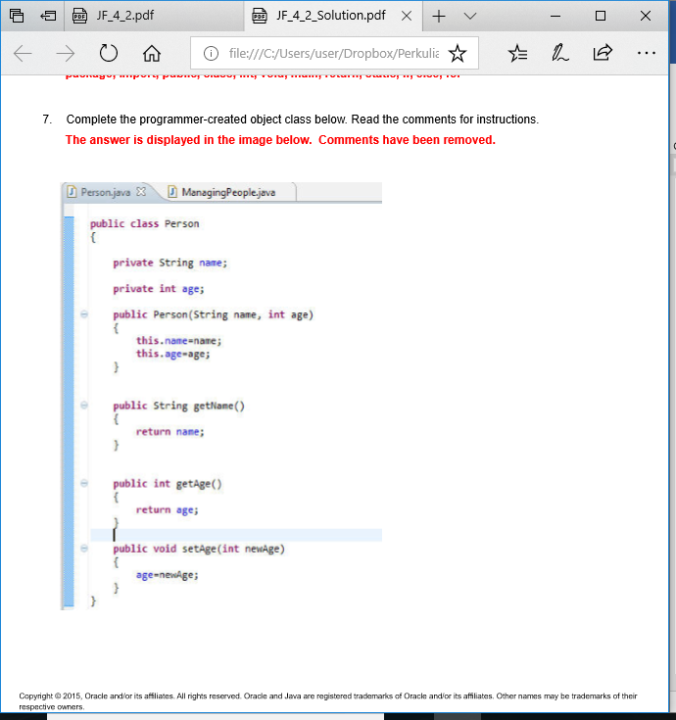

1. Buat driver kelas, namai dengan ManagingPeople.java seperti gambar di bawah ini. Kemudian compile dan jalankan. Berikan penjelasan untuk source code yang anda tuliskan.

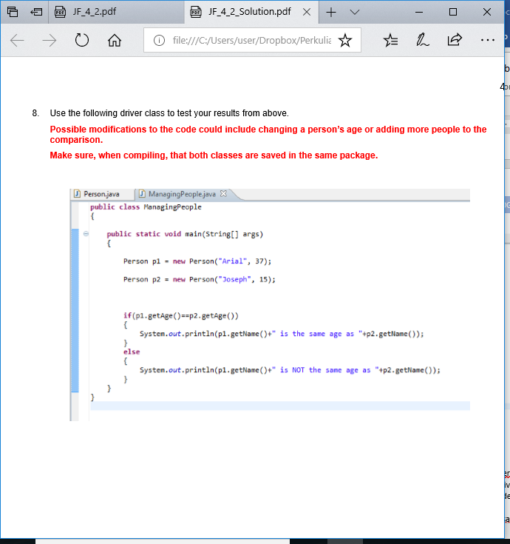

1. Sebutkan setidaknya 20 keyword di java.

LATIHAN:

1. Buatlah sebuah object class Student yang memiliki variabel studentID, name, NIM, IPK. Kemudian buatlah method setter dan getter nya. (anda bisa melihat modul/slide)
2. Buatlah driver class untuk menguji object class yang anda buat al, membuat objek, memanggil method dan mencetak data objek Student. (anda bisa melihat modul/slide)
3. Jalankan program yang anda buat! Tuliskan hasilnya!
4. Catat hasil yang anda peroleh dari step nomor 5 & 6, kemudian berikan penjelasan bilamana perlu.

***Setelah sesi praktikum SELESAI, laporan praktikum harus dikirim/diupload ke google classroom pada hari yang berikutnya.***